NIGERIAN INSTITUTE OF ARCHITECT ANAMBRA STATE CHAPTER EXECUTIVES

POST: CHAIRMAN
ARC. DR. IKENNA MICHAEL ONUORAH, MNIA, PhD, MAARCHES
Dr. Onuorah obtained his Bachelor of Science degree in Architecture from the Department of Architecture, Nnamdi Azikiwe University, Awka. He further obtained his Postgraduate degrees (Master of Science and Doctor of Philosophy) in Architecture with a special interest in Afrocentric/ vernacular architecture.
He is a distinguished scholar in the field of architecture and has published over to articles both in international and national journals.
He has worked in private and public sectors, including Dwellins International Limited, Physical Planning Unit of Nnamdi Azikiwe University, Awka. He is a Lecturer in the Department of Architecture at Nnamdi Azikiwe University, Awka, Anambra State, Nigeria.
He has served NIA Anambra state chapter as treasurer and also in many committees in different capacities. He is currently representing the state in NIA in council and Admissions committee.

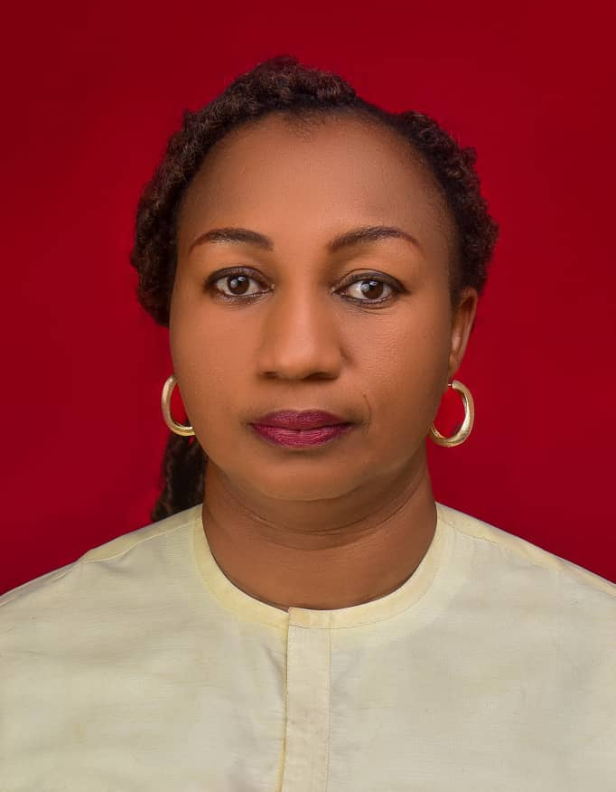

POST: VICE CHAIRMAN
ARC. OBIANUJU MIRIAM JONAS, MNIA
She obtained her Bachelor of Technology (B.Tech) and Master of Technology (M.Tech) from the department of architecture in Abubakar Tafawa Balewa University, (ATBU) Bauchi State.
She has worked both in private and public sectors and currently a Lecturer in the Department of Architecture at University of Nigeria Enugu Campus, Enugu State, Nigeria.


POST: GENERAL SECRETARY
ARC. SOPURUCHI S. ONIEFUNA, MNIA
He obtained his Bachelor of Science degree and Master of Science degree in Architecture from the Department of Architecture, Nnamdi Azikiwe University, Awka.
He is a seasoned Architect and Administrator with over 12 years of architectural practice experience in private & public service. As a Principal Architect of the Physical Planning Unit at Nnamdi Azikiwe University, he oversees the development of building design, construction and maintenance of infrastructure projects, ensuring sustainability and efficient space management of the university's physical infrastructure under the supervision of the Director of the Physical Planning Unit.



POST: ASSISTANT GENERAL SECRETARY
ARC. DR. IRVING IZUCHUKWU OKOYEH, MNIA
Dr. Irving Izuchukwu Okoyeh is a distinguished scholar in the field of architecture and urban planning, with an extensive academic and professional background. Holding a B.Sc, M.Sc, and Ph.D. in Architecture from Nnamdi Azikiwe University, Awka. Dr. Okoyeh has developed a deep expertise in architectural theory, design, and practice. Complementing this, he earned a Master’s degree in Urban and Regional Planning from the University of Nigeria, Nsukka, which has enriched his understanding of urban development and spatial planning. Dr. Okoyeh is a chartered architect, registered with the Architects Registration Council of Nigeria (ARCON), and is a full member of the Nigerian Institute of Architects (NIA). He is committed to advancing architectural knowledge and practice, bridging theoretical insights with practical applications in both academic and professional settings.

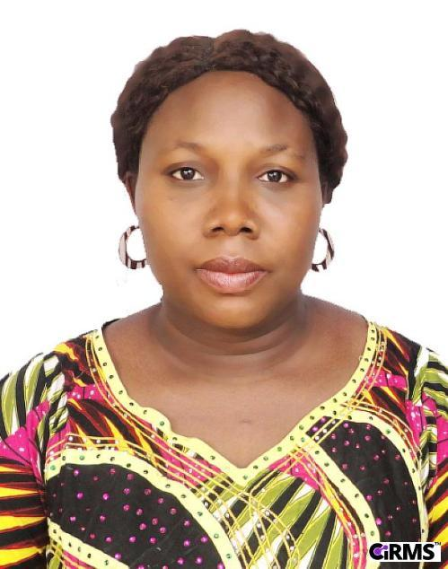
POST: TREASURER
Arc. Mrs. Ugochi Chizorom Aniakor MNIA
Lecturer at Nnamdi Azikiwe University, Awka
Department of Architecture.
Treasurer, Nigerian Institute of Architects
Anambra State Chapter
President, Eziowelle Anglican Women Association.


POST: FINANCIAL SECRETARY
Arc. Chibuzor J. Okoli,
B.sc, M.sc Jos. (2011, 2016)
Financial Secretary, NIA, Anambra State Chapter.
Consulting Partner and Creative director - Okolarc Limited.
Consultant - Anambra Urban Regeneration Council (ARUC)
Consultant- Anambra Development & Investment Coporation (ADIC)
He has previously worked with Design assistant Sports solutions and Architect Deckard Tyler Limited, Abuja.


POST: PUBLIC RELATION OFFICER
Principal Architect of the Physical Planning Unit at Nnamdi Azikiwe University,aWKA
He has his Bachelor of science (BS.c) from the Department of Architecture at University of Nigeria Enugu Campus, Enugu State, Nigeria and Master of Science degree in Architecture (M.Sc) from Department of Architeture in Nnamdi Azikiwe University, Awka. He is a chartered Architect.

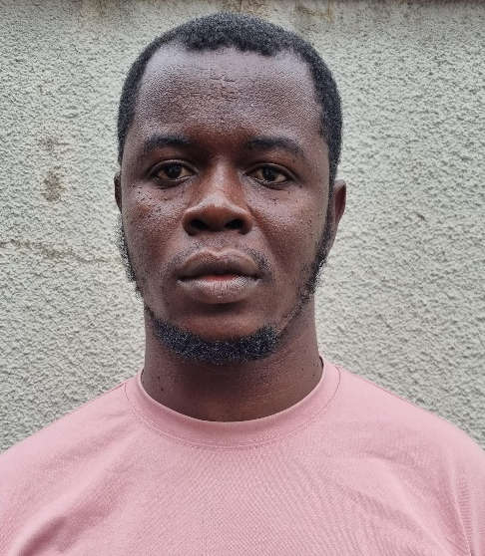

POST: PROVOST
Arc. Chukwunonso Igweze, MNIA
Principal Architect at NONITEK Concepts LTD
He obtained his Bachelor of science (BS.c) in Architecture from Department of Architeture in Nnamdi Azikiwe University, Awka and Master of Science in Architecture (M.Sc) from Chukwuemeka Odumegwu Ojukwu University, Uli. He is a chartered Architect.

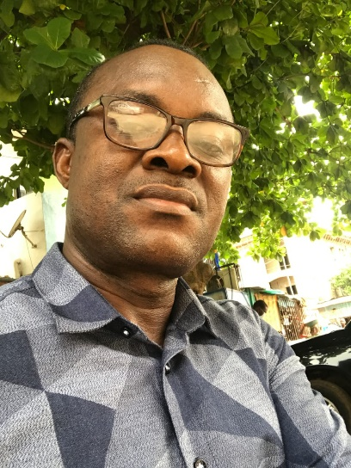
POST: EX-OFFICIO I
Arc. Osita Paul Okafor, MNIA
Arc. Osita Paul Okafor is the immediate past Chairman of the Nigerian Institute of Architects, Anambra State Chapter.
He has practiced extensively in public and private sector. He is currently the Deputy Director Architecture in Physical Planning Unit of Nnamdi Azikiwe University, Awka


POST: EX-OFFICIO II
Arc. Hon. Ifeanyi Azuka Okoye, MNIA
Arc. Hon. Ifeanyi Azuka Okoye is the immediate past vice chairman of the Nigerian Insitute of Architects, Anambra State Chapter.
He is a former law member in Anambra State Government, a chartered Architect and has worked extensively in private sector.

NIAASC WORKING COMMITTEE’S

GOVERNANCE INTERFACE COMMITTEE
Arc. Don Amaechi Ifejika - Chairman
Arc. Hon. Ifeanyi Azuka Okoye – Vice Chairman
Arc. Dr. Iwuchukwu Okafor – Member
Arc. Dr. Ikenna Ezennia – Member
Arc. Kelechi Mbanugo – Member
Arc. Amaobi Nwafor – Member
Arc. Hon. Chisom Ejabuka – Secretary

PUBLIC RELATION’S COMMITTEE
Arc. Zelunjo B.N. Okeje – Chairman
Arc. Nnamaka Ugochukwu Nzewi – Vice Chairman
Arc. Uzodinma Kenechukwu Igwegbe – Member
Arc. Ugochi Chizorom Aniakor - Member
Arc. Uzodinma Daniel – Secretary

LIBRARY AND PUBLICATIONS COMMITTEE
Assoc. Prof. B.N. Obiadi – Chairman
Arc. Dr. Oluchi Ifebi - Vice Chairman
Arc. Dr. Chijioke Chinyere Onwuziligbo – Member
Arc. Chike Jang Onyeneto
Arc. Obianuju Miriam Jonas – Secretary
Arc. Dr. Patricai Kio – Member
Arc. Nnamaka Ugochukwu Nzewi – Member
Arc. Onwubalili - Member
Arc. Dr. Ikenna Michael Onuorah – Member
Arc. Dr. Paschal U. Mbah – Member
Arc. Dr. Irving I. Okoyeh – Member

PRACTICE COMMITTEE
Arc. Okechukwu Innocent Ezeobi – Chairman
Arc. Osita Paul Okafor – Vice Chairman
Arc. Zelunjo B.N. Okeke - Secretary
Arc. Ikpechukwu Okafor - Member
Arc. Ifeoma Nwafor – Member
Arc. Chibuzor Okoli - Member
Arc. Henry Ozoemena – Member

COMMITTEE ON ARCHITECTURAL EDUCATION
Arc. Dr. Ikenna Michael Onuorah – Ag. Chairman
Assoc. Prof. B.N. Obiadi - Vice Chairman
Arc. Obianuju Miriam Jonas – Member
All HOD of Schools of Architecture within the State - Member
Arc. Okoyeh Irving – Member
Arc, Sopuruchi Nice Obiefuna – Secretary

STUDENT AFFAIRS COMMITTEE
Arc. Augustine Aniegbuna – Chairman
Arc. Chukwunonso Igweze – Member
ASA President of Schools of Architecture within the State – Member
Arc. Dr. Ikenna Michael Onuorah – Mmeber
Arc. Dr. Chijioke Chinyere Onwuziligbo – Member
Arc. Onwubalili - Member
Arc. Sopuruchi Nice Obiefuna – Secretary

ANNUAL LECTURE COMMITTEE
Arc. Nnamaka Ugochukwu Nzewi - Chairman
Arc. Sopuruchi Nice Obiefuna- Secretary
Arc. Obianuju Miriam Jonas - Member
Arc. Dr. Chijioke Chinyere Onwuzuluigbo - Member
Arc. Hon. Chisom Alpha Ejabukwa - Member
Arc Daniel Uzodimnma - Member
Arc. Ugochukwu Umeadi - Member
Arc. Ugochi Chizorom Aniakor - Member
Arc Zelunjo B.N. Okeke - Member
Arc. Dr. Ikenna Michael Onuorah – Member
Arc. Osita Paul Okafor - Member
Arc Ifeanyi Azuka Okoye - Member
Arc. Peter Okpala - Member

SOCIAL HANGOUT COMMITTEE
Arc. Dr. Paschal U. Mbah – Chairman
Arc. Ezekute Ifeanyi Arinze – Member
Arc. Dr. Ikenna Michael Onuorah– Member
Arc. Dr. Calistus C. Okafor – Member
Arc. Myka
Arc. Grant Ifeanyi
Arc. Chijioke Ezeokwelume – Secretary

BUILDING COLLAPSE/ RAPID RESPONSE TEAM
Arc, Sopuruchi Nice Obiefuna – Chairman
Arc. Osita Paul Okafor – Member
Arc Zelunjo B.N. Okeke - Member
Arc, Ifeanyi Arinze Ezekute
Arc. Obianuju Miriam Jonas - Member
Arc. Chukwunonso Igweze
Arc. Dr. Ikenna Michael Onuorah – member
Arc. Dr. Chijioke Chinyere Onwuzuluigbo - Secretary

